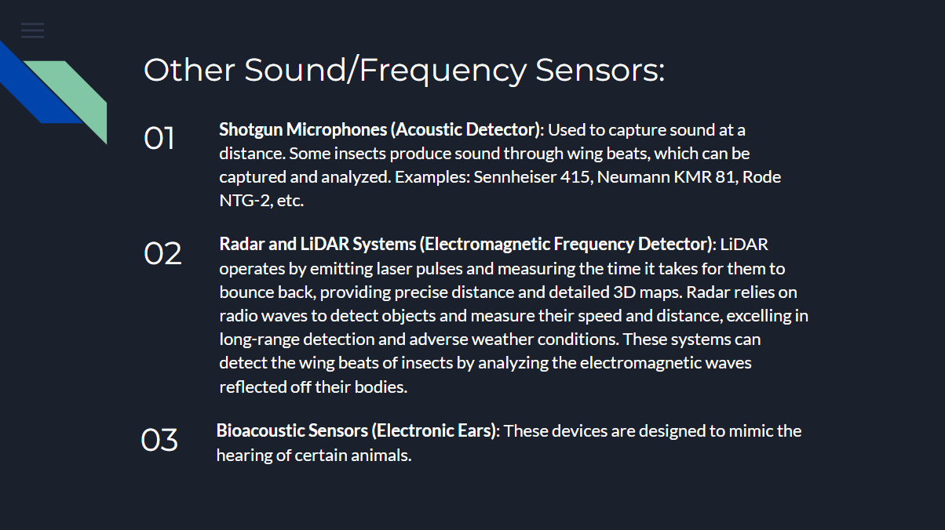

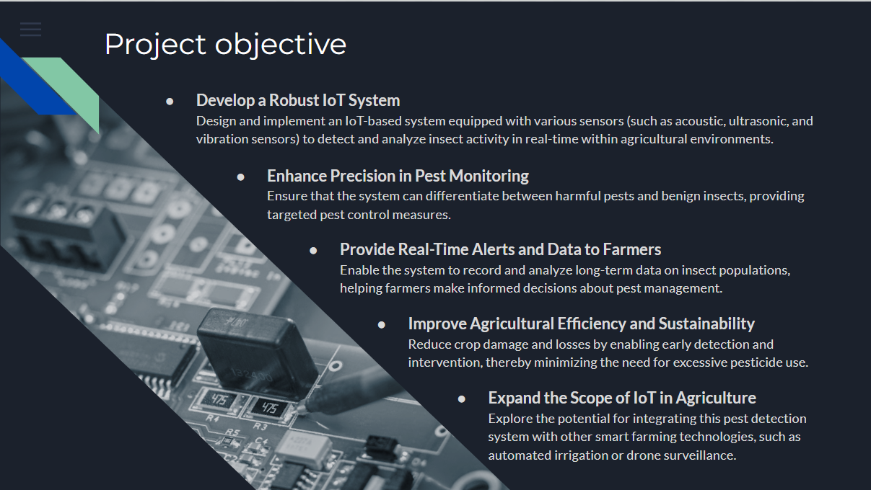

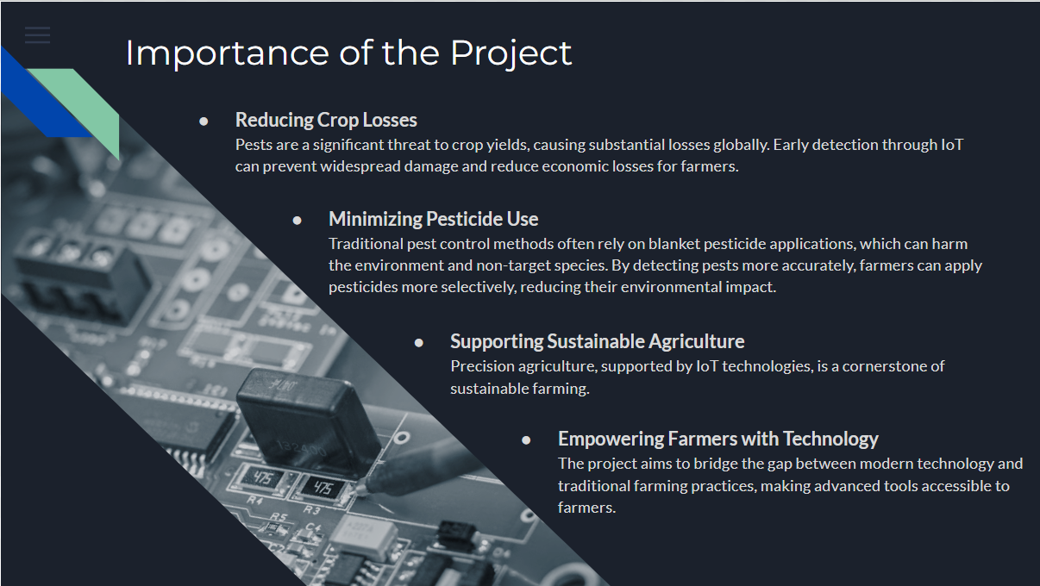

**The Impact of Insects on Farms**

Insects play a significant role in the agricultural ecosystem, but not always in a beneficial way. While some insects are vital pollinators, others are notorious for causing extensive damage to crops, leading to reduced yields and economic losses for farmers. Pests such as aphids, caterpillars, beetles, and locusts can ravage fields, feeding on leaves, stems, roots, and fruits, often decimating entire crops in a short period. The consequences are particularly severe in large-scale farming operations where infestations can spread rapidly, requiring extensive and often costly interventions.

Traditional methods of pest control, such as pesticide application, can be effective but also bring their own challenges, including environmental harm and the potential for pests to develop resistance.

**The Undetected Sounds of Insects**

Despite their small size, insects are constantly communicating with their environment and each other through a variety of sounds. These sounds, often imperceptible to the human ear, are crucial for their survival and behavior. Insects produce sounds for various reasons: to attract mates, ward off predators, or coordinate movements within a group. For instance, crickets chirp by rubbing their wings together, while certain beetles make clicking sounds to communicate.

However, these sounds often go undetected in the noisy backdrop of a farm. The hum of machinery, the rustle of leaves, and even the ambient noise of wind and rain can easily mask the subtle frequencies emitted by insects. This makes it challenging for farmers to detect early signs of pest infestations purely by observation. By the time visible damage is noticed, it might be too late to prevent significant crop loss.

The ability to detect these sounds could be a game-changer in pest management. If farmers could monitor the acoustic signals of insects in real-time, they could identify and respond to infestations much earlier, potentially saving crops before the damage becomes widespread. This is where technology, particularly IoT and advanced sensors, can play a transformative role. By capturing and analyzing the sounds of insects, these systems can alert farmers to the presence of pests long before they become visible, enabling more precise and effective interventions.

In conclusion, while insects can pose a severe threat to agriculture, understanding and detecting the sounds they produce offers a promising avenue for improving pest control and safeguarding crop yields.

ABOUT THE IoT MODEL:

Parts:

1. Arduino UNO
2. DEVMO High Sensitivity Sound Detection Module
3. Breadboard
4. Jumper Wires

**Project Explanation:**

In this project, an Arduino UNO board will be connected to a high-sensitivity frequency sensor, which is designed to detect specific frequencies emitted by pests. These frequencies are unique to certain insects, allowing the sensor to distinguish them from other sounds in the environment, such as wind or machinery noise. The Arduino UNO acts as the central control unit, processing the signals received from the frequency sensor.

The system will be deployed in various parts of the field, creating a network of monitoring stations that continuously listen for pest activity. When the frequency sensor detects the particular sound frequencies associated with pests, the Arduino UNO immediately triggers a response. It sends a signal to a motor, which is mounted on a pesticide or insecticide spray system, similar to a sprinkler.

Upon activation, the motor drives the spray system, dispersing the pesticide or insecticide in the affected area for a few minutes. This targeted approach ensures that the pests are either killed or repelled, minimizing the damage they can cause to the crops. The system then resets and continues to monitor for further pest activity, ensuring continuous protection of the field.

This automated, real-time pest control method is highly efficient, reducing the need for blanket pesticide applications and focusing resources precisely where they are needed. By responding only to the presence of pests, the system helps to conserve pesticides, lower costs, and reduce environmental impact, all while safeguarding crop health and yield.

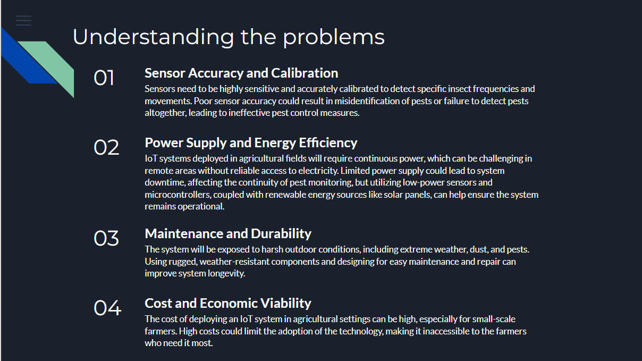

### ****Data Transmission and Connectivity****

* **Problem**: IoT systems rely on consistent data transmission to relay information to farmers or central servers. In rural areas, connectivity issues such as weak signals or limited network coverage could hinder data transmission.
* **Impact**: Loss of connectivity could result in delays in receiving alerts or incomplete data logs, reducing the effectiveness of the system.
* **Mitigation**: Exploring options like long-range (LoRa) communication protocols, mesh networks, or satellite communication could improve connectivity. Buffering data locally until a connection is re-established can also help.

### ****Educational and Research Opportunities****

* **Academic Research**: The project could serve as a foundation for further academic research, exploring new ways to apply IoT in agriculture or expanding into related fields like plant health monitoring, disease detection, or soil analysis.
* **Educational Tools**: Develop the system as an educational tool for agricultural students, helping them learn about IoT, pest management, and sustainable farming practices through hands-on experience.

### ****IoT-Enabled Ecosystem for Pest Control****

* **Automated Pest Management**: Integrate the IoT detection system with automated pest control mechanisms, such as smart traps or targeted pesticide sprayers. This could lead to the development of fully automated pest management systems that operate with minimal human intervention.
* **Collaborative Platforms**: Create a platform where data from multiple farms using your system can be aggregated and analyzed. This would enable collective insights and collaborative pest management strategies across regions, enhancing overall agricultural productivity.

### ****Integration with Other Smart Farming Technologies****

* **Precision Agriculture**: Expand the system to integrate with other precision agriculture tools, such as automated irrigation systems, soil sensors, and weather stations. This would create a comprehensive smart farming ecosystem that optimizes all aspects of crop management.
* **Drones and Robotics**: Incorporate drone technology or autonomous ground robots equipped with your IoT sensors to monitor larger areas more efficiently and even apply targeted pest control measures.

### ****Environmental and Sustainability Impact****

* **Reduction in Pesticide Use**: As the system becomes more precise and reliable, it could significantly reduce the need for broad-spectrum pesticide applications, leading to more sustainable farming practices and a lower environmental footprint.
* **Conservation Efforts**: The system could be adapted to monitor endangered insect species or beneficial insects like pollinators, contributing to conservation efforts and biodiversity protection.

